Bug_id_01
Bug Description:
New Password field does not show any hint or validation message (e.g., "Use at least 6 characters, 1 uppercase, 1 number, 1 special character") when the user focuses on it. This can lead to weak passwords or user confusion.
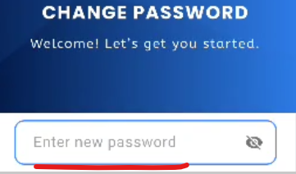

Bug_id_02
Bug Description:
New Password error message shows incomplete text ending with "..."(e.g., " Must contain at least one uppercase lett..."). This makes the validation unclear and confusing to the user.
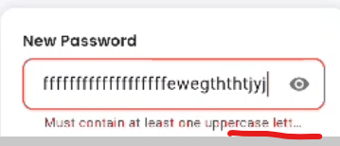

Bug_id_03
Bug Description:
Password validation shows errors one by one (first capital letter, then symbol, then number) instead of displaying all requirements at once, making the process confusing and repetitive for the user.

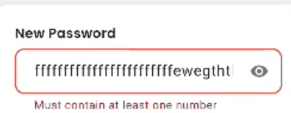
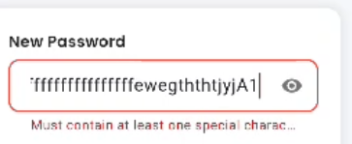

Bug_id_04
Bug Description:
New Password and Confirm Password fields accept unlimited characters with no maximum length validation, which may lead to UI issues, backend errors, or security concerns.
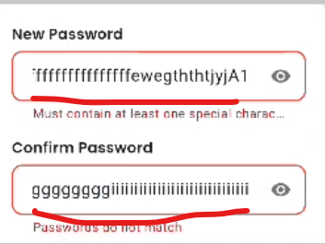
Bug_id_05
Bug Description:
When rotating the phone to horizontal (landscape) mode on the Change Password screen, the UI does not adjust properly — only the logo and heading are visible, while the input fields are squeezed into a small space at the bottom, requiring excessive scrolling and making the form difficult to view or use.
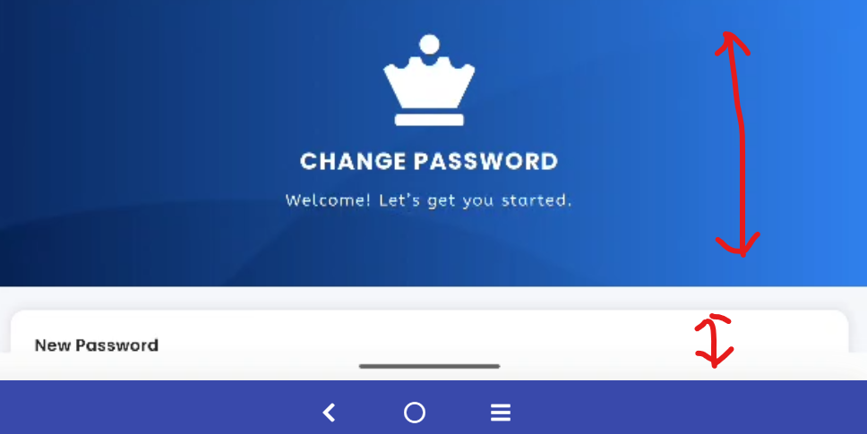

Bug_id_06
Bug Description:
On the Change Password page, the "New Password" input field unnecessarily expands in height when all password requirements (uppercase, symbol, number) are met, causing abrupt UI layout shifts and poor visual stability.
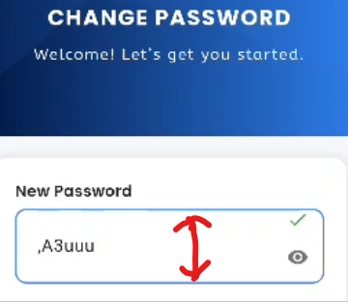
Bug_id_07
Bug Description:
On the Change Password page, the "Confirm Password" input field unnecessarily expands in height when all password requirements (uppercase, symbol, number) are met, causing abrupt UI layout shifts and poor visual stability.
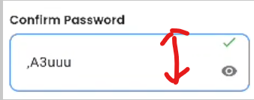
Bug_id_08
Bug Description:
The Change Password page allows setting the new password the same as the existing password without showing any error. It also shows a success popup saying "Password changed successfully", which is wrong because the password was not actually changed. This is a security issue.
